**20 Top-Rated Tourist Attractions in Rome**

**antiquity, intersperse , kick back**

In a city so filled with icons of …antiquity………………………… and the Christian faith, it's hard to know where to go first. Of course, your own interests will govern your choices, but there are certain sites that are almost obligatory landmarks of Italy and [top attractions in the world](https://www.planetware.com/world/top-rated-tourist-attractions-in-the-world-cam-1-40.htm), such as the Colosseum and the Pantheon.

A word of caution: try to vary your experiences as you explore Rome, so that you don't visit too many ancient sites or churches in a row. And …intersperse………………………. these more serious attractions with a few that are simply tourist icons: the Spanish Steps and that place all tourists must go to toss in their coin, the Trevi Fountain.

Rome is so big that it can overwhelm, so even the most devoted sightseer should take some time to …kick back…………………….. and enjoy la dolce vita in a park or sidewalk café. You'll be able to choose the best places to visit with this handy list of the top attractions in Rome.

**1. The Colosseum and the Arch of Constantine**

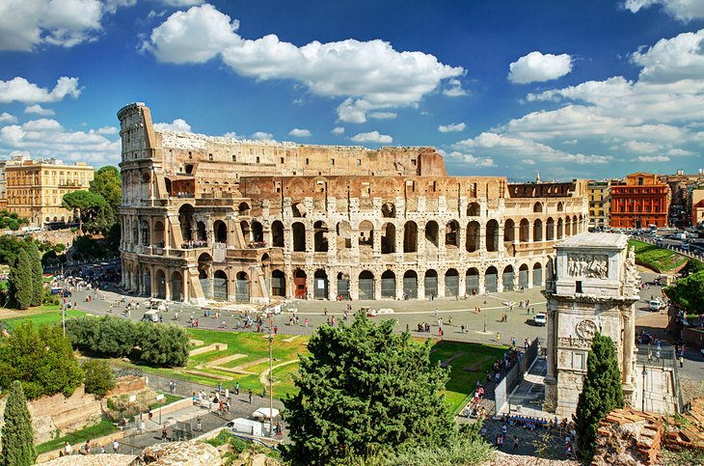

The Colosseum and the Arch of Constantine

**oval, erected, splendid, populace,**

As the Eiffel Tower is to Paris, the silhouette of the Flavian Amphitheatre is to Rome. The largest structure left to us by Roman antiquity, the Colosseum still provides the model for sports arenas - present day football stadium design is clearly based on this …oval…………….Roman plan.

The building was begun by Vespasian in AD 72, and after his son Titus enlarged it by adding the fourth story, it was inaugurated in the year AD 80 with a series of …splendid…………………..games. The Colosseum was large enough for theatrical performances, festivals, circuses, or games, which the Imperial Court and high officials watched from the lowest level, aristocratic Roman families on the second, the …populace………………….on the third and fourth.

Beside the Colosseum stands the almost equally familiar Arch of Constantine, a triumphal arch …erected………………….by the Senate to honor the emperor as "liberator of the city and bringer of peace" after his victory in the battle of the Milvian Bridge in 312. Lines are long and move slowly, so you can save time by joining the [Skip the Line: Ancient Rome and Colosseum Half-Day Walking Tour](https://www.viator.com/tours/Rome/Skip-the-Line-Ancient-Rome-and-Colosseum-Half-Day-Walking-Tour/d511-3731COLOSSEUM?eap=planetware-tours-14254&aid=vba14254en) and have a knowledgeable guide, as well.

**2. Vatican City**

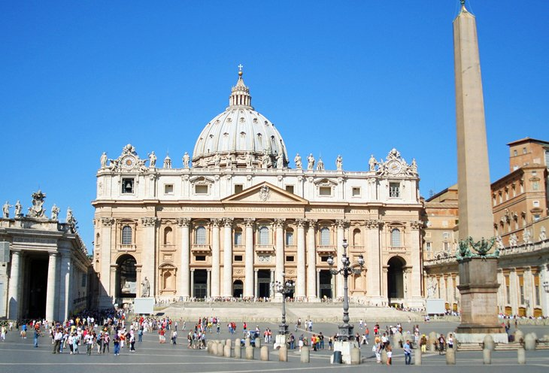

Vatican City

**state, unquestioned, supreme,**

The Vatican is the smallest independent …state………………in the world, with an area of less than half a square kilometer, most of it enclosed by the Vatican walls. Inside are the Vatican palace and gardens, **St. Peter's Basilica**, and **St. Peter's Square**, an area ruled by the Pope, …supreme……………..head of the Roman Catholic Church. This compact space offers a lot of things to see, between its museums and the great basilica itself.

Inside St. Peter's Basilica is **Michelangelo's masterpiece, Pieta**, along with statuary and altars by Bernini and others. The …unquestioned………………….highlight of the Vatican museums is the **Sistine Chapel**, whose magnificent frescoed ceiling is Michelangelo's most famous work.

In the Vatican Palace are the **Raphael Rooms**; the **Borgia Apartments**; the **Vatican Library**, and a number of museums that include the Picture Gallery, Museum of Secular Art, Etruscan Museum, and others. The collections you can see in these cover everything from papal coaches to 20th-century art reflecting religious themes.

Ticket lines for the [Vatican's top attractions](https://www.planetware.com/tourist-attractions-/vatican-city-scv-scv-rvc.htm) are incredibly long, and you can spend several hours waiting in line. To save time, purchase a [Skip the Line: Vatican Museums with St. Peter's, Sistine Chapel, and Small-Group Upgrade](https://www.viator.com/tours/Rome/Skip-the-Line-Vatican-Museums-Walking-Tour-including-Sistine-Chapel-Raphaels-Rooms-and-St-Peters/d511-3731VATICAN?eap=planetware-tours-14254&aid=vba14254en) tour in advance. This three-hour tour allows you to bypass the long lines and walk straight into the museums with a knowledgeable guide. Headsets are provided, and you can choose from several different departure times or upgrade to an evening or small-group tour.

**3. The Pantheon**

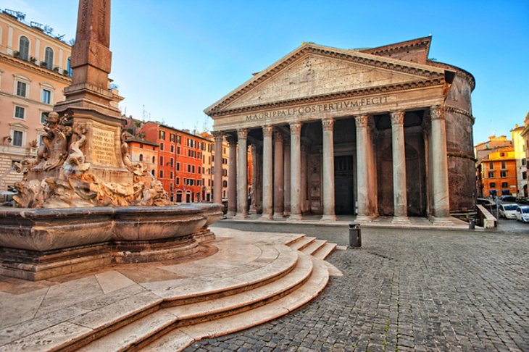The Pantheon

**preserved, suspended, emperors, worship, canopy, stripped,**

The Pantheon - the best-preserved……………………….. monument of Roman antiquity - is remarkably intact for its 2000 years. This is despite the fact that Pope Gregory III removed the gilded bronze roof tiles, and Pope Urban VIII ordered its bronze roof ……………………..and melted down to cast the ………………………..over the altar in St. Peter's and cannons for Castel Sant'Angelo.

The Pantheon was rebuilt after damage by fire in AD 80, and the resulting brickwork shows the extraordinarily high technical mastery of Roman builders. Its 43-meter dome, the supreme achievement of Roman interior architecture, hangs…canopy………………… without visible supports – these are well hidden inside the walls – and its nine-meter central opening is the building's only light source.

The harmonious effect of the interior is a result of its proportions: the height is the same as the diameter. Although the first Christian…………………. forbade using this pagan temple for ………………………, in 609 Pope Boniface IV dedicated it to the Virgin and all the Christian martyrs, and since then, it has become the burial place of Italian kings (Victor Emmanuel II is in the second niche on the right) and other famous Italians, including the painter, Raphael.

* Read More: [Visiting the Pantheon in Rome: Highlights, Tips & Tours](https://www.planetware.com/rome/pantheon-i-la-rp.htm)

**4. Roman Forum**

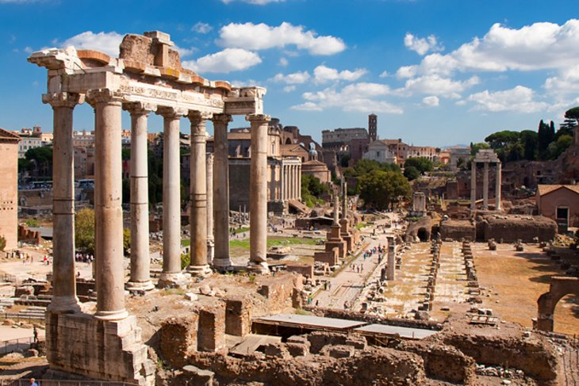Roman Forum

**stepping back, excavations, splendor , fortresses**

Walking through the forum, now in the middle of a throbbing modern city, is like ……………………..two millennia into the heart of ancient Rome. Although what survives of this center of Roman life and government shows only a small fraction of its original……………………., the standing and fallen columns, its triumphal arches, and remains of its walls still impress, especially when you consider that for centuries, the history of the Forum was the history of the Roman Empire and of the Western world.

Roman political and religious life was centered here, along with the courts, markets, and meeting places. After the seventh century, the buildings fell into ruin, and churches and …………………………. were built amid the ancient remains. Its stones were quarried for other buildings and it was not until the 18th and 19th centuries that systematic ……………………….brought the ancient buildings to light from under a 10-meter layer of earth and rubble.

**5. Trevi Fountain**

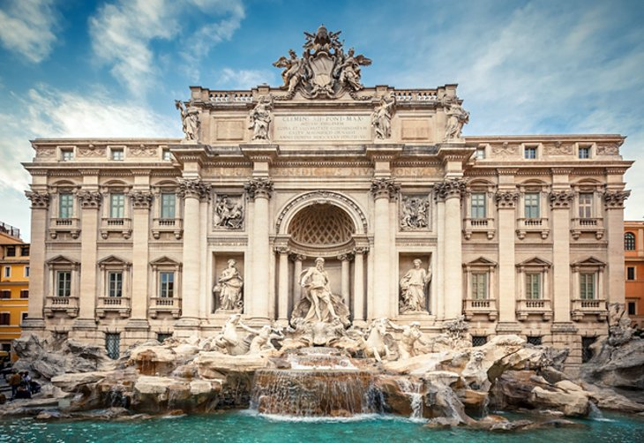Trevi Fountain

**aqueduct , swirls, depicts**

One of the city's most popular tourist attractions, this 17th-century masterpiece has been immortalized in films until it is almost a required visit. Throwing a coin (not three) into the Trevi Fountain (Fontana di Trevi) is a tradition that is supposed to assure your return to Rome.

Rome's largest fountain, Fontana di Trevi is supplied by an ………………….originally constructed by Agrippa, the great art patron of the first century BC, to bring water to his baths. The fountain was created for Pope Clement XII between 1732 and 1751 by Nicolò Salvi, and built against the rear wall of the palace of the Dukes of Poli.

It …………………………the sea god Oceanus (Neptune), with horses, tritons, and shells. The water …………………….around the figures and the artificial rocks, and collects in a large basin, always filled with coins.

**6. Vittorio Emanuele II Monument**

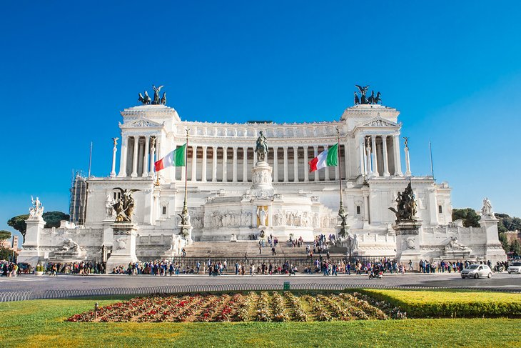Vittorio Emanuele II Monument

**grandiose, equestrian, unification**

It's ironic that this …………………..monument, considered one of the national symbols of Italy, is rarely admired by Romans, who liken it to a wedding cake or a giant typewriter. Like it or not, the vast neo-classical structure crowns Capitoline Hill, symbolic center of ancient Rome, overlooking the later city across Piazza Venezia.

Built between 1885 and 1935, it is a monument to King Vittorio Emanuele II, the first king of the unified Italy, represented here in an …………………..statue. Italy's the tomb of the unknown soldier is here, along with a museum of the Italian ……………………….. A lift will take you to the topmost terrace for 360-degree views of Rome.

Address: Piazza Venezia, Rome

**7. Centro Storico & the Spanish Steps**

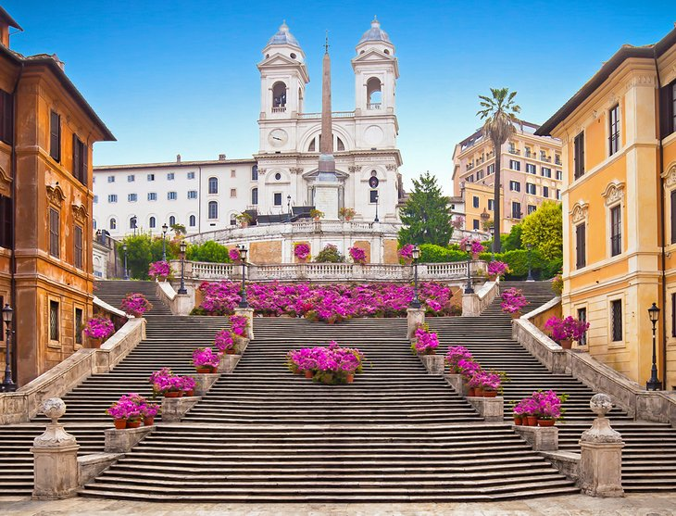The Spanish Steps

**resplendent, strolling , at the foot,**

Take a look at a Rome tourist map, and you'll see one area so filled with things to do that it's hard to read the street names. This is the Centro Storico, the historic center of Rome, with so many art-filled churches, ……………………….palaces, and lively squares that you could spend your whole vacation ……………………..its ancient streets and lanes.

Spend some time just to absorb the neighborhood's atmosphere instead of going from one of its must-see sights to the next. Along with **Piazza Navona**, the **Trevi Fountain**, and the **Basilica of Santa Maria Maggiore**, stop in less well-known churches, such as **Santa Maria del Popolo**, where you'll find works by Bernini and Caravaggio.

Pause at the Spanish Steps, the flight of irregular stairs and landings that lead up to the French church of Trinità dei Monti. The stairs take their name from **Piazza di Spagna**, the plaza at their base and one of Rome's most typical squares. The stairs have long been a favorite haunt of tourists.

The boat-shaped fountain ……………………of the Spanish Steps is known as the **Barcaccia** and was created by Pietro Bernini, father of the great Baroque architect Gian Lorenzo Bernini. **Via Condotti**, leading southwest from Piazza di Spagna, is Rome's most fashionable shopping street, where the **Caffè Greco** is famous for the artists, writers, and musicians who have frequented it.

Address: Piazza di Spagna, Rome

**8. Santa Maria Maggiore**

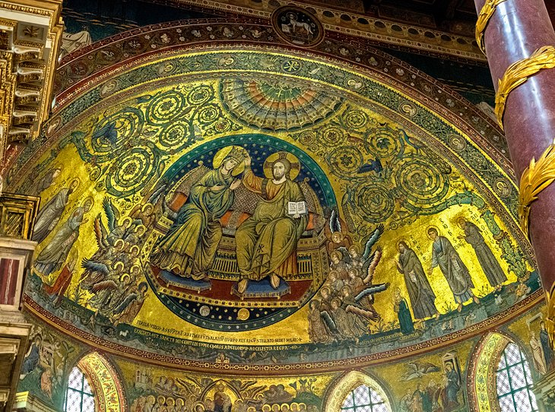Santa Maria Maggiore

**marble, inlaid , pilgrimage**

One of Rome's most majestic churches, Santa Maria Maggiore has stood here since the fourth-century Pope Liberius had a vision of the Virgin directing him to build a church where snow fell the following day. Although it was August, snow did fall on the Esquiline hill the next morning, so here the great basilica was built.

Mass has been celebrated here every day since the fifth century. The three aisles of its 86-meter-long interior are separated by 40 columns of ……………………….and four of granite, and the apse added in the 13th century is lined with mosaics of Old and New Testament themes, masterpieces of Rome's famous mosaic artists.

Rome's oldest mosaics, as old as the fourth century, decorate the upper walls, and the floor is ………………………with colored stone in the style of the expert 12th-century artisans of the Lake Como region. The first gold to reach Italy from the Americas shines on the coffered ceiling. Two popes are buried here; it's one of Rome's four papal basilicas, an important place of ……………………….

Address: Piazza di Santa Maria Maggiore, Rome

**9. Piazza Navona**

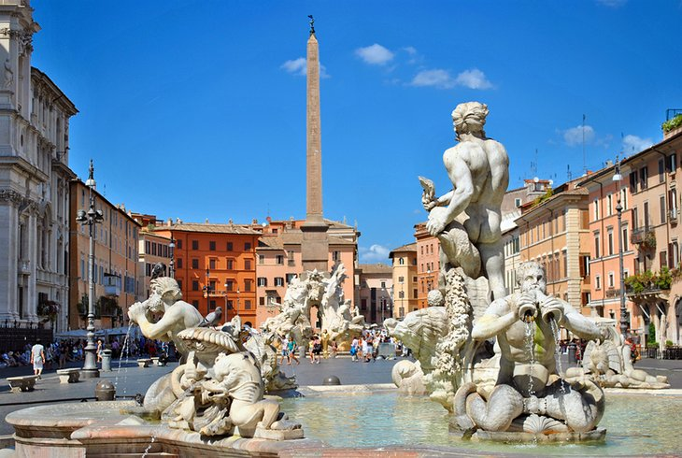Piazza Navona

**squares, centerpiece ,accompanied, gables**

One of Rome's most characteristic Baroque …………………………., Piazza Navona still has the outline of the Roman stadium built here by Emperor Domitian. It was still used for festivals and horse races during the Middle Ages, and was rebuilt in the Baroque style by Borromini, who also designed the magnificent series of palaces and the church of **Sant'Agnese,** on its west side.

Its facade, campanile, and dome highlight the way Baroque architecture weaves convex and concave surfaces, …………………….., windows, columns, and piers into a unified design. In the crypt of Sant'Agnese are Alessandro Algardi's 1653 *The Miracle of St. Agnes*and the remains of a Roman mosaic floor. Sant'Agnese provided a model for Baroque and Rococo churches in Italy and elsewhere.

Although Borromini designed the square and its surrounding facades, it was his archrival, Bernini, who created its………………………….., the beautiful Baroque fountain, **Fontana dei Fiumi**. The spirited fountain represents the four rivers then thought to be the largest on each of the known continents, with figures personifying the Nile, Ganges, Danube, and Rio de la Plata around the large basin, each…………………………….. by plants and animals of their respective regions.

The two other fountains in the square are the 16th-century **Fontana del Moro** in front of the Palazzo Pamphili, erected by Giacomo della Porta, and the 19th-century **Fontana del Nettuno** with its figure of Neptune. Today, the square is filled with Romans, tourists, street artists, souvenir kiosks, cafés, and during December, one of Rome's best Christmas markets.

Nearby, between the Piazza and the **Pantheon**, the church of **San Luigi dei Francesi** contains three major paintings by Caravaggio from the late 16th century.

**10. Piazza del Popolo & Santa Maria del Popolo**

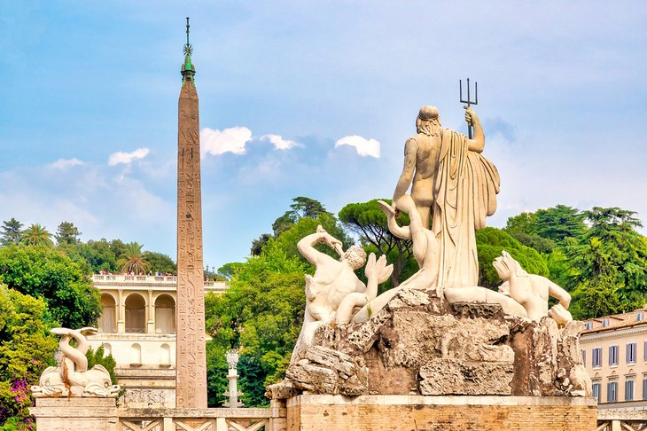Piazza del Popolo

Symmetrically situated at the apex of a triangle of streets that include Via Corso, Rome's main shopping street, Piazza del Popolo was designed in the early 19th century as the northern entrance to the city center. At its center, the Egyptian obelisk, called Flaminio, rises above a fountain, where four white marble lions spout fans of water into four round travertine pools.

Facing one side like mirror images at either side of Via Coorso are the twin churches of Santa Maria dei Miracoli and Santa Maria in Montesanto, and at the opposite side of the grand piazza is the Augustinian Basilica of Santa Maria del Popolo.

Inside, you'll find Pinturicchio frescoes and two tombs by Andrea Sansovino in the choir, and two beautiful chapels. The **Chigi Chapel** was designed by Raphael in 1515, and the **Cesari Chapel** holds two important Caravaggio paintings.

Next to the basilica, climb the steps to the **Pincio Terrace** for views down onto the piazza and across the city of Rome.

**11. Palatine Hill**

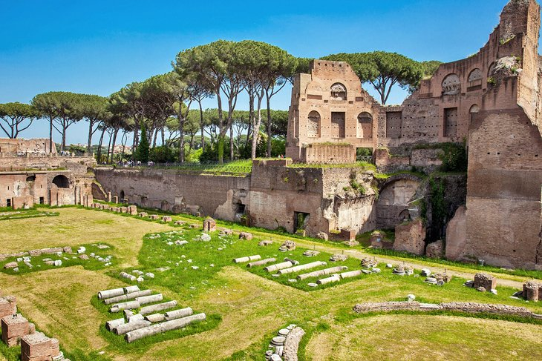The Stadium of Domitian on Palatine Hill

**settlement , emperors , imposing, terraces**

Strategically set 50 meters above the Tiber, the Palatine Hill shows evidence of Rome's earliest ………………………..: rock-cuttings found in front of the Temple of Cybele show human activity as long ago as the ninth century BC. Later, this was the site chosen by the emperors and great aristocratic families for their palaces.

The **Farnese Gardens** were laid out on the hill in the 16th century for Cardinal Alessandro Farnese, a pleasure park of…………………….., pavilions, lawns, flowerbeds, trees, and fountains designed as a kind of stage-setting for social gatherings.

[Highlights of the Palatine Hill](https://www.planetware.com/rome/palatine-hill-i-la-rph.htm) are the **House of Livia** (Augustus' wife), the semi-subterranean **Cryptoporticus**, **Domus Flavia**, **Domus Augustana,** and most ……………………….of all, the **Baths of Septimius Severus.** The Palatine Hill is a lovely place to explore, combining a park with magnificent and impressive ruins of ancient Rome.

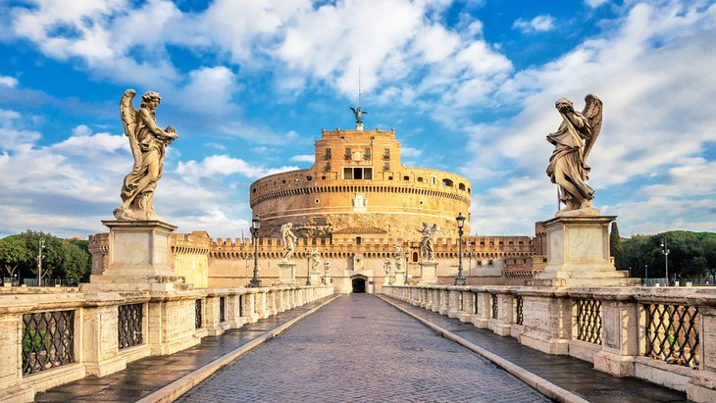Castel Sant'Angelo

**overlooking, treasury, guarding**

Begun in AD 135 as a mausoleum for the Emperor Hadrian and his family, Castel Sant'Angelo is a massive drum-shaped structure …………………… the Tiber near the Vatican. Over the millennia of its existence, Castel Sant'Angelo has been used as a papal residence and a fortress, and more recently as a National Museum.

In AD 271, Emperor Aurelian took advantage of its position …………………….. the northern approaches to the city and incorporated it into his new system of walls surrounding the city. As a bastion it protected the city from barbarian attacks, and by the Middle Ages had become a substantial fortress. In times of peril, popes fled here across a secret elevated corridor, the **Passetto di Borgo**, and stored their most precious riches in the castle's ………………………………….

Visitors reach the castle across a pedestrian bridge lined with statues of angels (by Bernini), and ascend to its five floors on a spiral ramp. At its various levels are prison cells, a large collection of weapons, and splendidly decorated **papal apartments** covered in Renaissance frescoes. At the top is a terrace with stunning views of the city.

Address: Lungotevere Castello 50, Rome